https://www.kyototourism.org/en/column/21793/

Discover Unique Sake Breweries Across Kyoto より、一部抜粋

Joyo-Shuzo (Kyoto Tea Country area)

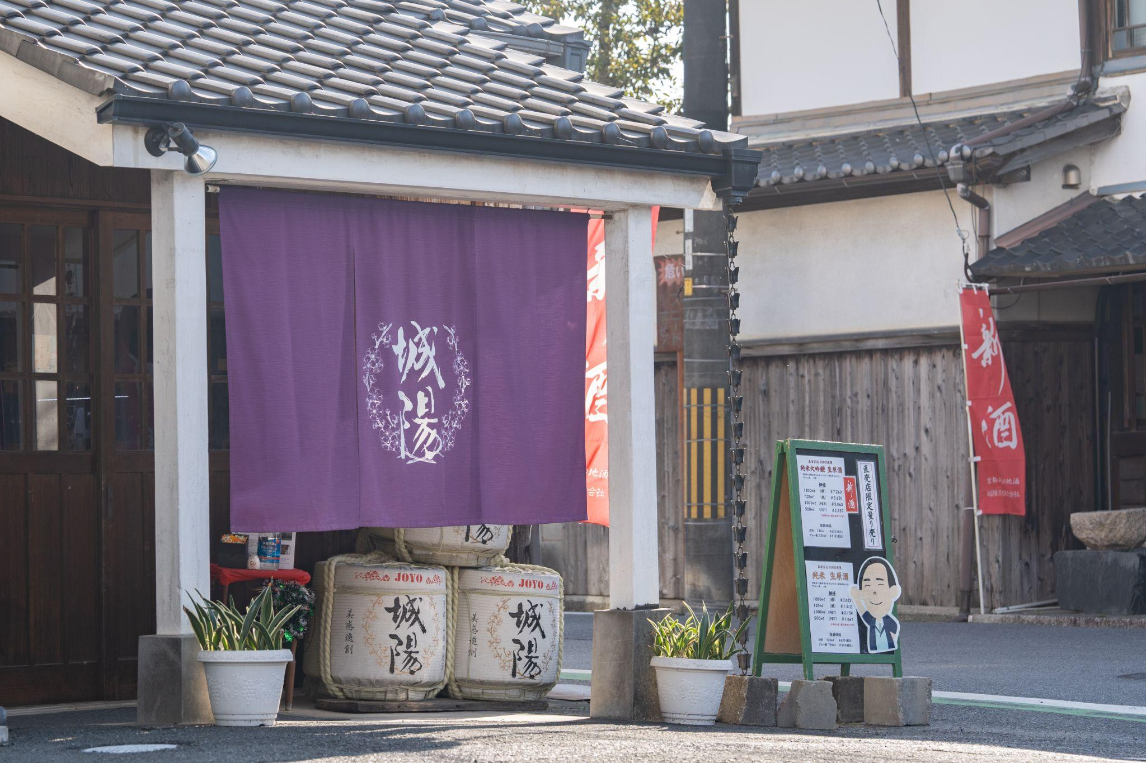

Founded in 1895, Joyo-Shuzo is the only sake brewery in the Kyoto Tea Country area, and the southernmost sake brewery in Kyoto Prefecture. The brewery buildings, which have been there since the founding, exude a historical charm. Joyo-Shuzo offers a wide variety of sake, with a broader range of brewing than most breweries. This is due to their use of three different rice varieties. (Just as grape varieties like Pinot Noir and Chardonnay determine the types of wine produced, rice varieties are crucial in sake brewing.)

既存の写真

One of the three rice varieties, Iwai, is extraordinary. It is only available in Kyoto Prefecture and is special to Kyoto brewers. This is worth mentioning because of years of research and development carried out by breweries, academics, and the government for the creation of the best sake rice in accordance with the terroir including water and climate of Kyoto. This reflects the region's serious commitment to providing the highest quality sake rice to breweries. In fact, Joyo-Shuzo’s sake made with Iwai, Tokubetsu Junmai 60 "Joyo" was a gold winner in the SAKE division of the International Wine Challenge 2021. The excellent sake has a distinctive flavor and sharp acidity.

Moreover, Joyo-Shuzo uses very soft water for their sake production. This softness, characterized by lower mineral content including calcium and magnesium compared to other brewing waters, extends the period of fermentation process. As a result, it enhances the development of fruit and flower-like aromas, which are beautifully amplified particularly when served in a wine glass.

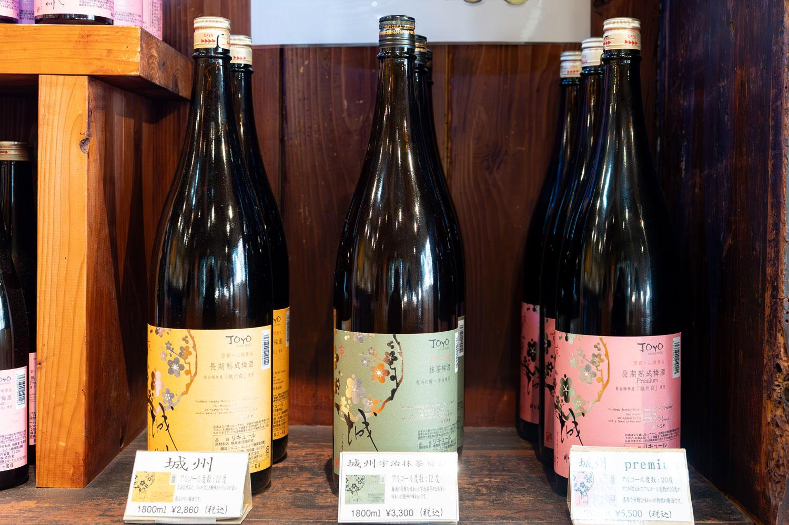↑
この写真に差し替え（Local gourmet spots near JR stations between Kyoto, Nara and Igaの記事のフォルダにいれています。）

While most sake breweries do not produce fruit liquor because of the difficulty in obtaining the license from the government, Joyo-Shuzo produces umeshu (Japanese plum wine), and even keeps records of how it matures. Normally, bottled umeshu should be consumed within 12 months from shipping, but Joyo-Shuzo successfully ages their umeshu for over 3 years. This is an exceptional achievement in brewing.

Among their umeshu, Aodani no Ume, aged for seven years, has a mellow flavor that is not overly sweet, leaving a refreshing aftertaste. Joyo city is well-known for its ume (Japanese plums) , especially for the Joshuhaku, a premium plum variety with a peach-like aroma. Joyo-Shuzo has been crafting umeshu since 1991, and they currently use 100% Joshuhaku, contributing to its popularity.

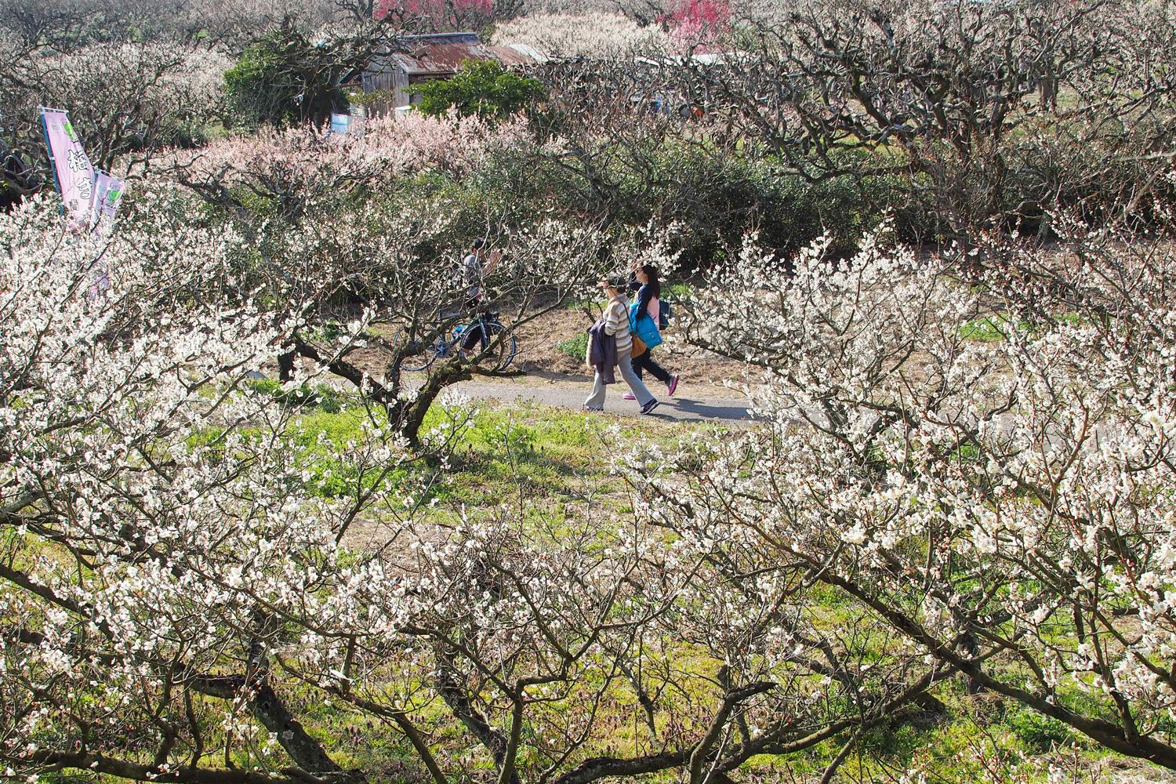↑
この写真に差し替え（Local gourmet spots near JR stations between Kyoto, Nara and Igaの記事のフォルダにいれています。）

Additionally, if you visit Joyo-Shuzo around late February to mid-March, you’ll be able to enjoy not just their umeshu, but the Plum Blossom Festival around nearby Aodani-Bairin Plum Grove. You can admire the beautiful white blossoms of the very Joshuhaku plum, among other plum blossoms.

Name (EN) : Joyo-Shuzo Co., Ltd.
Name (JA) : 城陽酒造株式会社
Address : 34-1 Nashima Kubono, Joyo City, Kyoto Prefecture 610-0116
URL : http://www.joyo-shuzo.co.jp/
TEL : 0774-52-0003

